**Technical Design Document (TDD)**

**Medical Inventory Optimization and Forecasting**

|  |  |
| --- | --- |
| **Mentors*:*** | **Authors:** |
| *Mr. Sampath Kumar*  **Mentor (Client):**  *Bharani Kumar Depuru*  *Sandeep* | *Mr. Ripan Debnath* |

Table of Contents

1. Introduction 4

1.1 Purpose 4

1.2 Scope 4

1.3 Document Organization 4

1.4 Audience 4

2. System Overview 5

2.1 Context 5

2.2 Product Feature 5

2.3 Technologies Used 5

3. Application Architecture 5

3.1 Architecture Design as per student perspective 5

3.2 Architecture Design as per video processing 6

3.2 System Operations 7

4. Database Architecture (Entity Relationship Diagram) 8

4.1 Database 8

4.2 Tag Generation and Storing 8

4.3 Models 8

5. Approach 9

5.1 Doc2Vec 9

5.2 TF-IDF Vector 9

5.3 SVM with SGD training 9

6. Assumption and Constraints 10

6.1 Students are registered 10

6.2 Recommend Modules for registered courses 10

6.3 Focus on model building 10

6.4 Video with clean audio not multiple voice interference 10

6.5 References 10

**Revision History**

|  |  |  |
| --- | --- | --- |
| Version | Date | Description |
| 1.0 | 25/02/2023 | Initial Draft |
| *2.0* | 08/04/2023 | Final Draft |

# Introduction

Pharmaceutical industry wants to develops, demand, producing their own drugs. The global pharmaceuticals market produced treatments worth over $1.2 trillion, and this industry serves hospitals and medical facilities worldwide. For demand of the drugs in hospital and maintain an sufficient drug inventory, hospital chains must developed their inventory management strategies. For solving this problem first we collect and analyze the large amount of data related to drug and patient demand. So hospital management ensure that they have correct drugs quantity for the patients.

## 1.1 Purpose

The purpose of this document is to outline the high-level design of the **Project Medical Inventory Optimization & Forecasting**and provide an overview for the tool implementation.

Its main purpose is to –

* Build an accurate forecasting model for pharmaceutical company.
* To Minimize bounced prescriptions due to drug shortages

## Scope

Goals: Forecast the number of drugs needed in hospital.

Minimize the shortage of drug and maximize the drug quantity

Business Success Criteria: To decrease bounce rate by 50% at least from the current scenario

ML Success Criteria: To provide the business model accuracy greater than 90%

Economic Success Criteria: Increase the revenue by atleast 20%

## 1.3 Document Organization

This document is organized into the following section:

|  |  |
| --- | --- |
| Introduction | Provides information related to the document |
| System Overview | Describes the approach, architectural goals and constraints, Guiding principles |
| Application Architecture | Describe the application architecture in terms of different layers of application. Description of the presentation layer, business layer, data access layer and resource layer and their relationship to each other. |
| Database Architecture | Describes the overall Data model and entity relationship diagram |
| Assumptions and Constraints | Details various assumptions made during design and development of the Online Screening tool |

## Audience

The intended audiences for this document are: -

* Innodatatics Inc.
* The project development team
* Mentors

# System Overview

## 2.1 Context

pharmacy, the [science](https://www.britannica.com/science/science) and art concerned with the preparation and standardization of [drugs](https://www.britannica.com/science/drug-chemical-agent). Its scope includes the cultivation of plants that are used as drugs, the synthesis of chemical [compounds](https://www.merriam-webster.com/dictionary/compounds) of medicinal value, and the analysis of medicinal agents. Pharmacists are responsible for the preparation of the dosage forms of drugs, such as tablets, capsules, and sterile solutions for injection. They [compound](https://www.merriam-webster.com/dictionary/compound) physicians’, dentists’, and veterinarians’ prescriptions for drugs. The science that embraces knowledge of drugs with special reference to the mechanism of their action in the [treatment](https://www.britannica.com/science/therapeutics) of disease is [pharmacology](https://www.britannica.com/science/pharmacology).

## 2.2 Product Feature

The major feature of the ***Project Medical Inventory Optimization & Forecsting*** will be the following:

* + **Streamlit –** Forecasted the drug quantity based on the day wise. If u click that day period so will get the next day or next month forecasted value.
* **Forecasting Double expression model –** he question will take query process and it extracts forecast results from the model.
  + **Information Extraction –** There will be a git hub for containing all the information needed, populated using information extraction technique

## Technologies Used

The Cloud API will be developed in Python streamlit app, Model will be implemented in Python. The frontend web application will be implemented using streamlit web app.

The system will have Machine Learning libraries too.

**Front-end –** Anaconda navigator

**Middleware (streamlit) –** Python,

**Backend –** Git hub repository

# Application Architecture

## 3.1 Architecture Design as per student perspective

**Front-end Application –** Web app with  receive date from users and get prediction

**REST API Services –** Receive HTTP GET request containing user query and forward them to ML based model

**ML Model –** Used single exponential smoothing, double exponential smoothing, Arima, Auto arima and predicted the demand.

**Database –** Store key words/labels in the database with module info

## 

## 3.2 Architecture Design as per video processing

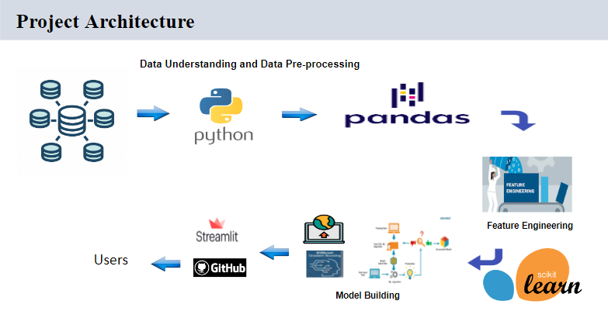

# Database Architecture (Entity Relationship Diagram)

## 4.1 Database

The healthcare management they provide high quality care to the patients. In this data set our main value is drug purchases, sales, patient details, and medical histories. The healthcare database is a central repository for all healthcare-related data, making it easily accessible to various departments within the healthcare organization. This includes clinical departments, such as radiology and pathology, as well as administrative departments, such as billing and finance.

## 4.2 Tag Generation and Storing

Tag data will be generated from existing course videos and store in the database. The tag generation will be done by our ML model.

Entity Relation diagram of database shown below: -

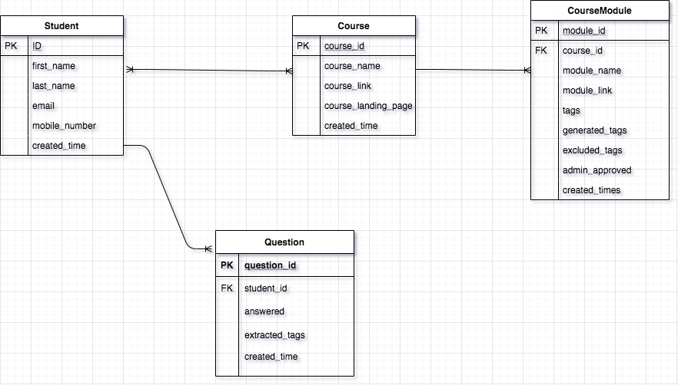

## Models

We used the following models:

1) Auto Regression

2) Simple Exponential Smoothing/ Holts Linear Method

3) Holt’s winter exponential smoothing with Additive Seasonality and Additive trend

4) Holt’s winter exponential smoothing with

Multiplicative seasonality and Additive trend

5) Holt’s winter exponential smoothing with Multiplicative Seasonality, Additive trend and Rolling Mean

6) ARIMA

7) AUTO- ARIMA

8) SARIMA

9) prophet

# Approach

We have tried ML approached to solve the issue which are listed below: -

Used double exponential smoothing to build the final model.

## 5.1 ML Building

Using ml library like ***statsmodels, prophet for model building***

## 5.2 Accuracy Score

To check the accuracy score we used library like ***sklearn.metrics***

# Assumption and Constraints

## 6.1 Department

There are three types of departments like dep1, dept2, dept3. So as we can see that dept3 having highest sales by quantity wise.

## Focus on model building

Our main focus is to developed a best time series model for healthcare industries.

## Video with clean audio not multiple voice interference

While building model extraction tags from video we found out that some of the video where multiple person are speaking it’s not able to convert video to text because of noise. So we have taken those video in consideration which has less noise.

## References